**Screenshot 1 – Initial Rendering of Basic Mars Outline Information**

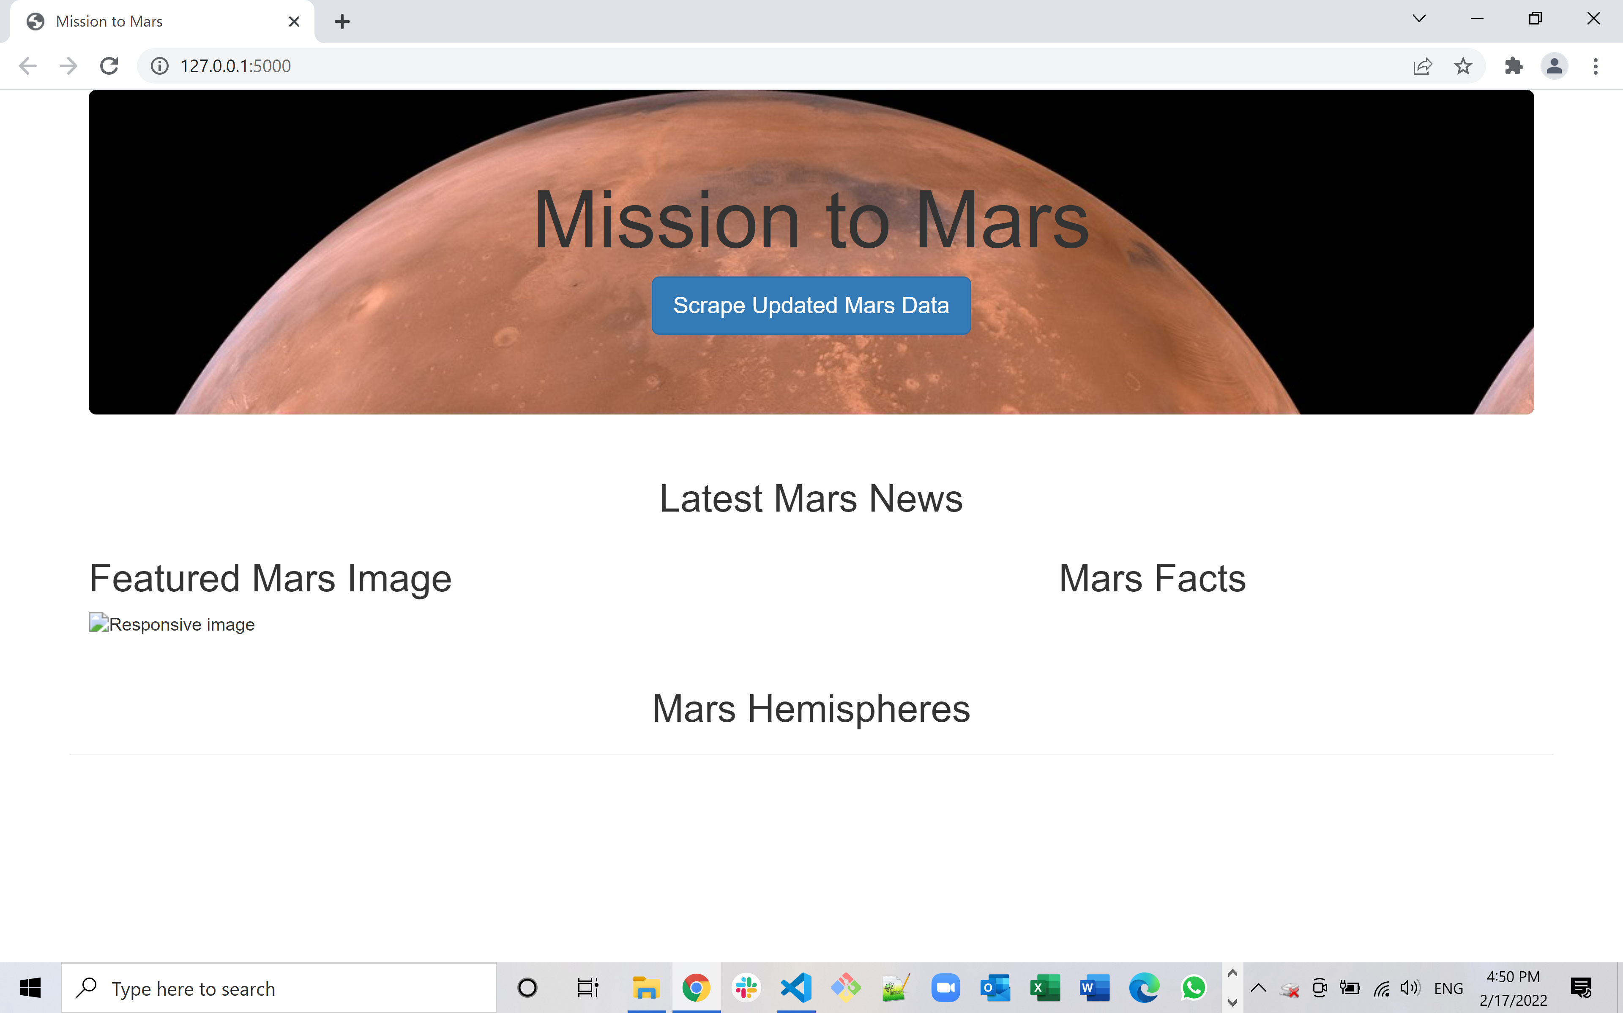

**Screenshot 2 – Top Section of Web Page After Scraping**

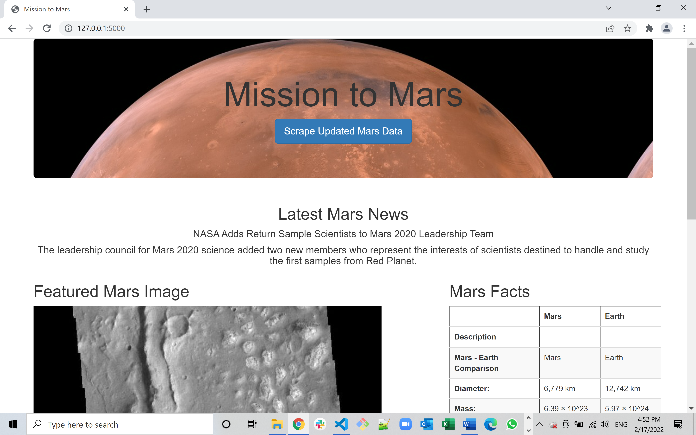

**Screenshot 3 – Middle Section of Web Page After Scraping**

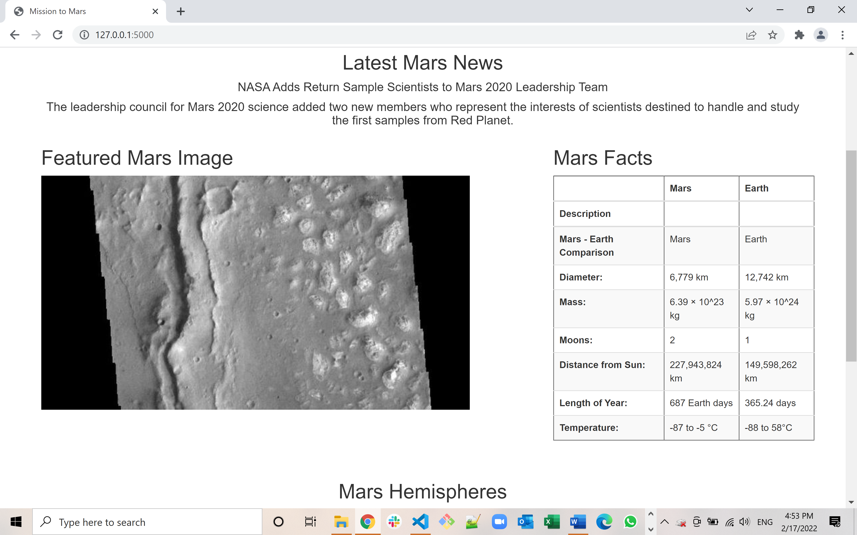

**Screenshot 4 – Bottom Section of Web Page After Scraping**

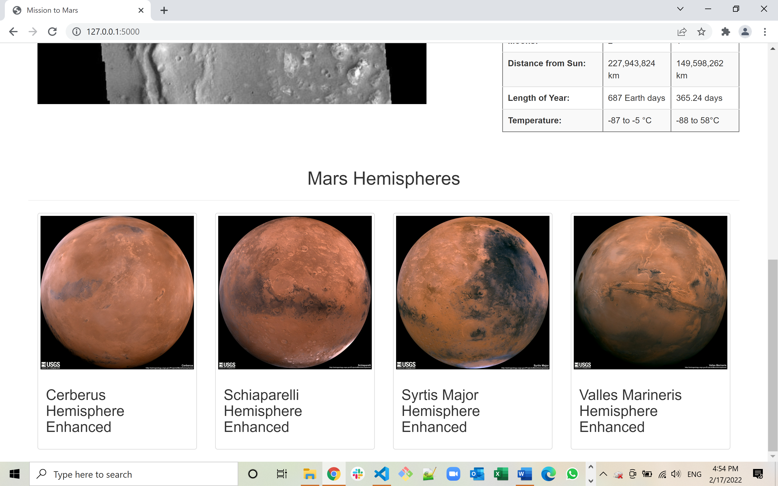

**Screenshot 5 –Responsive Web Page After Scraping**

